***MONOSTABLE MULTIVIBRATOR***

Experiment No: …………….

Date: ……. /……. /……………

**Aim**: To design an monostable multivibrator using transistor

***Equipment and Components Required***:

Dual Power supply (0-30V), Oscilloscope (0-30MHz), Transistor BC107, Resistors , Capacitors , Breadboard, Connecting wires,Probes

***Theory:***

A monostable multivibrator often called a one-shot multivibrator is a pulse generating circuit in which the duration of the pulse is determined by the RC network connected externally to the 555 timer. In a stable or stand-by state the output of the circuit is approximately zero or at logic low level. When an external trigger pulse is applied, the output is forced to go high (approx. Vcc). The time during which the output remains high is given by,

tp = 1.1 R1 C

At the end of the timing interval, the output automatically reverts back to its logic low state. The output stays low until a trigger pulse is applied again. Then the cycle repeats.

Thus the monostable state has only one stable state hence the name monostable

***Experiment Procedure:***

1. Get the required components
2. Give the connections as per circuit diagram. DEFINCENCY
3. A negative trigger pulse of 5V, 2 KHz is applied
4. Check the output using CRO
5. Measure the width and time period of the wave

***Circuit diagram***

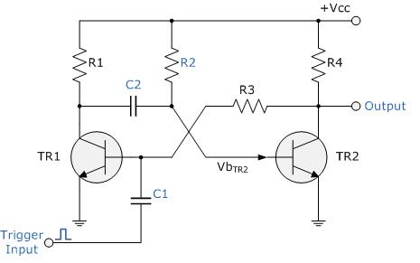

**Fig 3.1: Monostable Multivibrator Circuit**

**Working:**

* When the circuit is switched ON, transistor Q1 will be OFF and Q2 will be ON.
* Capacitor C1 gets charged during this state.
* When a positive trigger is applied to the base of transistor Q1 it turns ON, which turns OFF the transistor Q2 due the the negative voltage from the capacitor C1.
* Capacitor C1 starts discharging during this state.
* Transistor Q1 remains in ON state due the positive voltage from the collector of transistor Q2 which is in OFF state.
* Transistor Q2 remains in OFF state until the capacitor C1 discharges compleatly.
* When the capacitor C1 discharged completly, transistor Q2 turns ON, which turns transistor Q1 OFF.

**Design:**

Given f= ------ KHz,

### R – Collector Resistor:

### Rc should be calculated depending upon the collector current requirement.

**Rc  = ( Vcc – Vce (sat) ) / Ic**

### R1 – Base Resistor:

### R1 should be chosen such that it will provide enough collector current during saturation to the transistor Q2.

### Min. base current required, Ibmin = Ic / β, where β is the hFE of the transistor

* Safe base current, Ib = 3 Ibmin = 3Ic / β

**R1 = ( Vcc – Vbe ) / Ib**

### R2 – Base Resistor Q1:

### R2 should be chosen such that it should provide enough saturation collector current to the transistor Q1.

### R2 = (( Vcc – Vbe ) / Ib ) – R

### T – Pulse Time Period:

**T = 0.693R1C1**

From this we can find the value of capacitor C.

**C3 Capacitor:**

**Assume R3=1KΩ**

**R3C3 << 0.0016T**

**Model graph:**

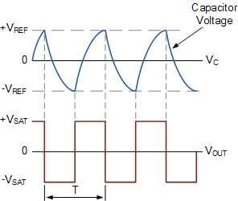

**Fig 3.2: Output of Monostable Multivibrator**

***Tabular column:***

|  |  |  |  |  |
| --- | --- | --- | --- | --- |
| **S.no** | **Observation** | **Amplitude**  **( No. of div x**  **Volts per div )** | **Time period**  **( No. of div x**  **Time per div )** | |
| **ton** | **toff** |
| 1 | Trigger input |  |  |  |
| 2 | Output Voltage , Vo |  |  |  |

***Conclusion:***

**ASTABLE MULTIVIBRATOR**

Experiment No: …………….

Date: ……. /……. /……………

**Aim**: To design an astable multivibrator using transistor

***Equipment and Components Required***:

Dual Power supply (0-30V), Oscilloscope (0-30MHz), Transistor BC107, Resistors , Capacitors , Breadboard, Connecting wires,Probes.

***Theory:***

An astable multivibrator, often called a free-running multivibrator, is a rectangular-wave-generating circuit. This circuit does not require an external trigger to change the state of the output. The time during which the output is either high or low is determined by two resistors and a capacitor, which are connected externally to the 555 timer. The time during which the capacitor charges from 1/3 Vcc to 2/3 Vcc is equal to the time the output is high and is given by,

tc = 0.69 (R1 + R2) C

Similarly the time during which the capacitor discharges from 2/3 Vcc to 1/3 Vcc is equal to the time the output is low and is given by,

td = 0.69 (R2) C

Thus the total time period of the output waveform is,

T = tc + td = 0.69 (R1 + 2 R2) C

The term duty cycle is often used in conjunction with the astable multivibrator. The duty cycle is the ratio of the time tc during which the output is high to the total time period T. It is generally expressed in percentage. In equation form,

% duty cycle = [(R1 + R2) / (R1 + 2 R2)] x 100

***Experiment Procedure:***

1. Get the required components
2. Give the connections as per circuit diagram
3. Check the out put using CRO
4. Measure the width and time period of the wave

**DESIGN:**

Given f= 4 KHz,

Therefore, Total time period, T = 1/f = ____________

We know, duty cycle = tc/ T



Therefore, tc = ------------------------

and td = ____________

We also know for an astable multivibrator

td = 0.69 (R2) C

Therefore, R2 = _____________

tc = 0.69 (R1 + R2) C

Therefore, R1 = _______

***Circuit diagram***

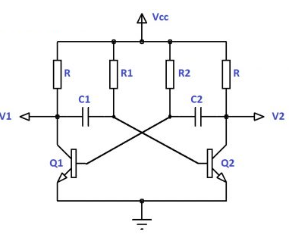

**Model graph:**

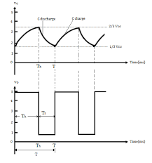

***Tabular column:***

|  |  |  |  |  |
| --- | --- | --- | --- | --- |
| **S.no** | **Waveforms** | **Amplitude**  **( No. of div x**  **Volts per div )** | **Time period**  **( No. of div x**  **Time per div )** | |
| **tc** | **td** |
| 1 | Output Voltage , Vo |  |  |  |
|  | | | | |

***Conclusion:***

***Thus the astable multivibratoris designed using transistor and its output was verified.***

***Viva Voce Questions:***

***1.*** What is a multivibrator ?

2.What is the purpose of multivibrator ?

3. What is an astable multivibrator called so ?

4.Why is an monostable multivibrator called so ?

5.What is an astable multivibrator ?

6.What is a monostable multivibrator ?

7. What is the purpose of monostable multivibrator ?

8.Give some examples of multivibrator.

***9.*** Mention the applications of multivibrator.

***10.*** What is the principle of monostable multivibrator ?

11. How does a monostable multivibrator work in terms of the astable multivibrator ?

***12.*** What is the disadvantage of an astable multivibrator ?

13. What are the different types of multivibrator circuits?

………………………………………………………………………………………………………………………………………

**BJT Differential Amplifier**

Experiment No: …………….

Date: ……. /……. /……………

**Aim**: To Study and Construct a differential amplifier using BJT and determine its CMRR.

***Equipment and Components Required***:

DC Power supply (0-30V), Resistors, BJT, Breadboard, Connecting wires

***Theory:***

The differential amplifier, or differential pair, is an essential building block in all integrated amplifiers. In general, the input stage of any analog integrated circuit with more than one input consists of a differential pair or differential amplifier. The basic differential pair circuit consists of two-matched transistors Q1andQ2 , whose emitters are joined together and biased a constant current source.Three important characteristics of the differential input stage are: the common-mode rejection ratio CMRR, the input differential resistance Rid , and the differential-mode gain Ad .

*Working principle:*

When input signal Vs1 is applied to the transistor Q1, there will be a high voltage drop across the collector resistance RC1  , and thus the collector of Q1 will be less positive. When Vs1 is negative Q1 is turned OFF, and the voltage drop across RC1 becomes very low and thus the collector of Q1 will be more positive. Thus we can conclude than an inserted output appears at Q1 collector for applying signal at Vs1. When Q1 is turned ON by the positive value of Vs1, the current through the emitter resistance RE  increases as the emitter current is almost equal to the collector current (IEIC). Thus the voltage drop across RE increases and makes the emitter of both transistors going in a positive direction. Making Q2’s emitter positive is the same as making the base of Q2 negative. In such a condition the transistor Q2 will conduct less current which in turn will cause less voltage drop in RC2 and thus the collector of Q2 will go in a positive direction for positive input signal. Thus we can conclude that the non-inverting output appears at the collector of transistor Q2 for input at base of Q1.The amplification can be driven differentially by taking output between the collector of Q1 and Q2

***Experiment Procedure:***

**PROCEDURE:**

1. Connections are given as per the circuit diagram.

2. Set the input Voltages V1 = 50mV & V2 =40mV.

3. Note down the Output Voltage

4. Vary the input Voltages and note down the output voltages.

***Circuit diagram***

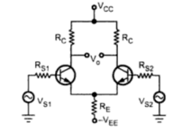

Design:

Assume Rc=4.7KΩ, Rs1=Rs2=100Ω, RE=6.8KΩ, hie=2.8KΩ, hfe=100

Differential Gain:



Common Mode Gain:



CMRR:



CMRR in db= 20 log CMRR

***Output Voltage:***







***WORKSHEET***

|  |  |  |  |
| --- | --- | --- | --- |
| SL NO | VI(V) | V2(V) | VO(V) |
|  |  |  |  |
|  |  |  |  |
|  |  |  |  |

***Conclusion:***

Thus the differential amplifier was designed and output was verified.

**VIVA QUESTIONS**

1. What is Differential amplifier?

1. Define CMRR.
2. What are the ideal characteristics for Differential amplifier?

4. How the emitter resistance RE affects the CMRR?

5. What are the advantages of differential amplifier using FET than differential amplifier using BJT?

6. What are the applications of differential amplifier?